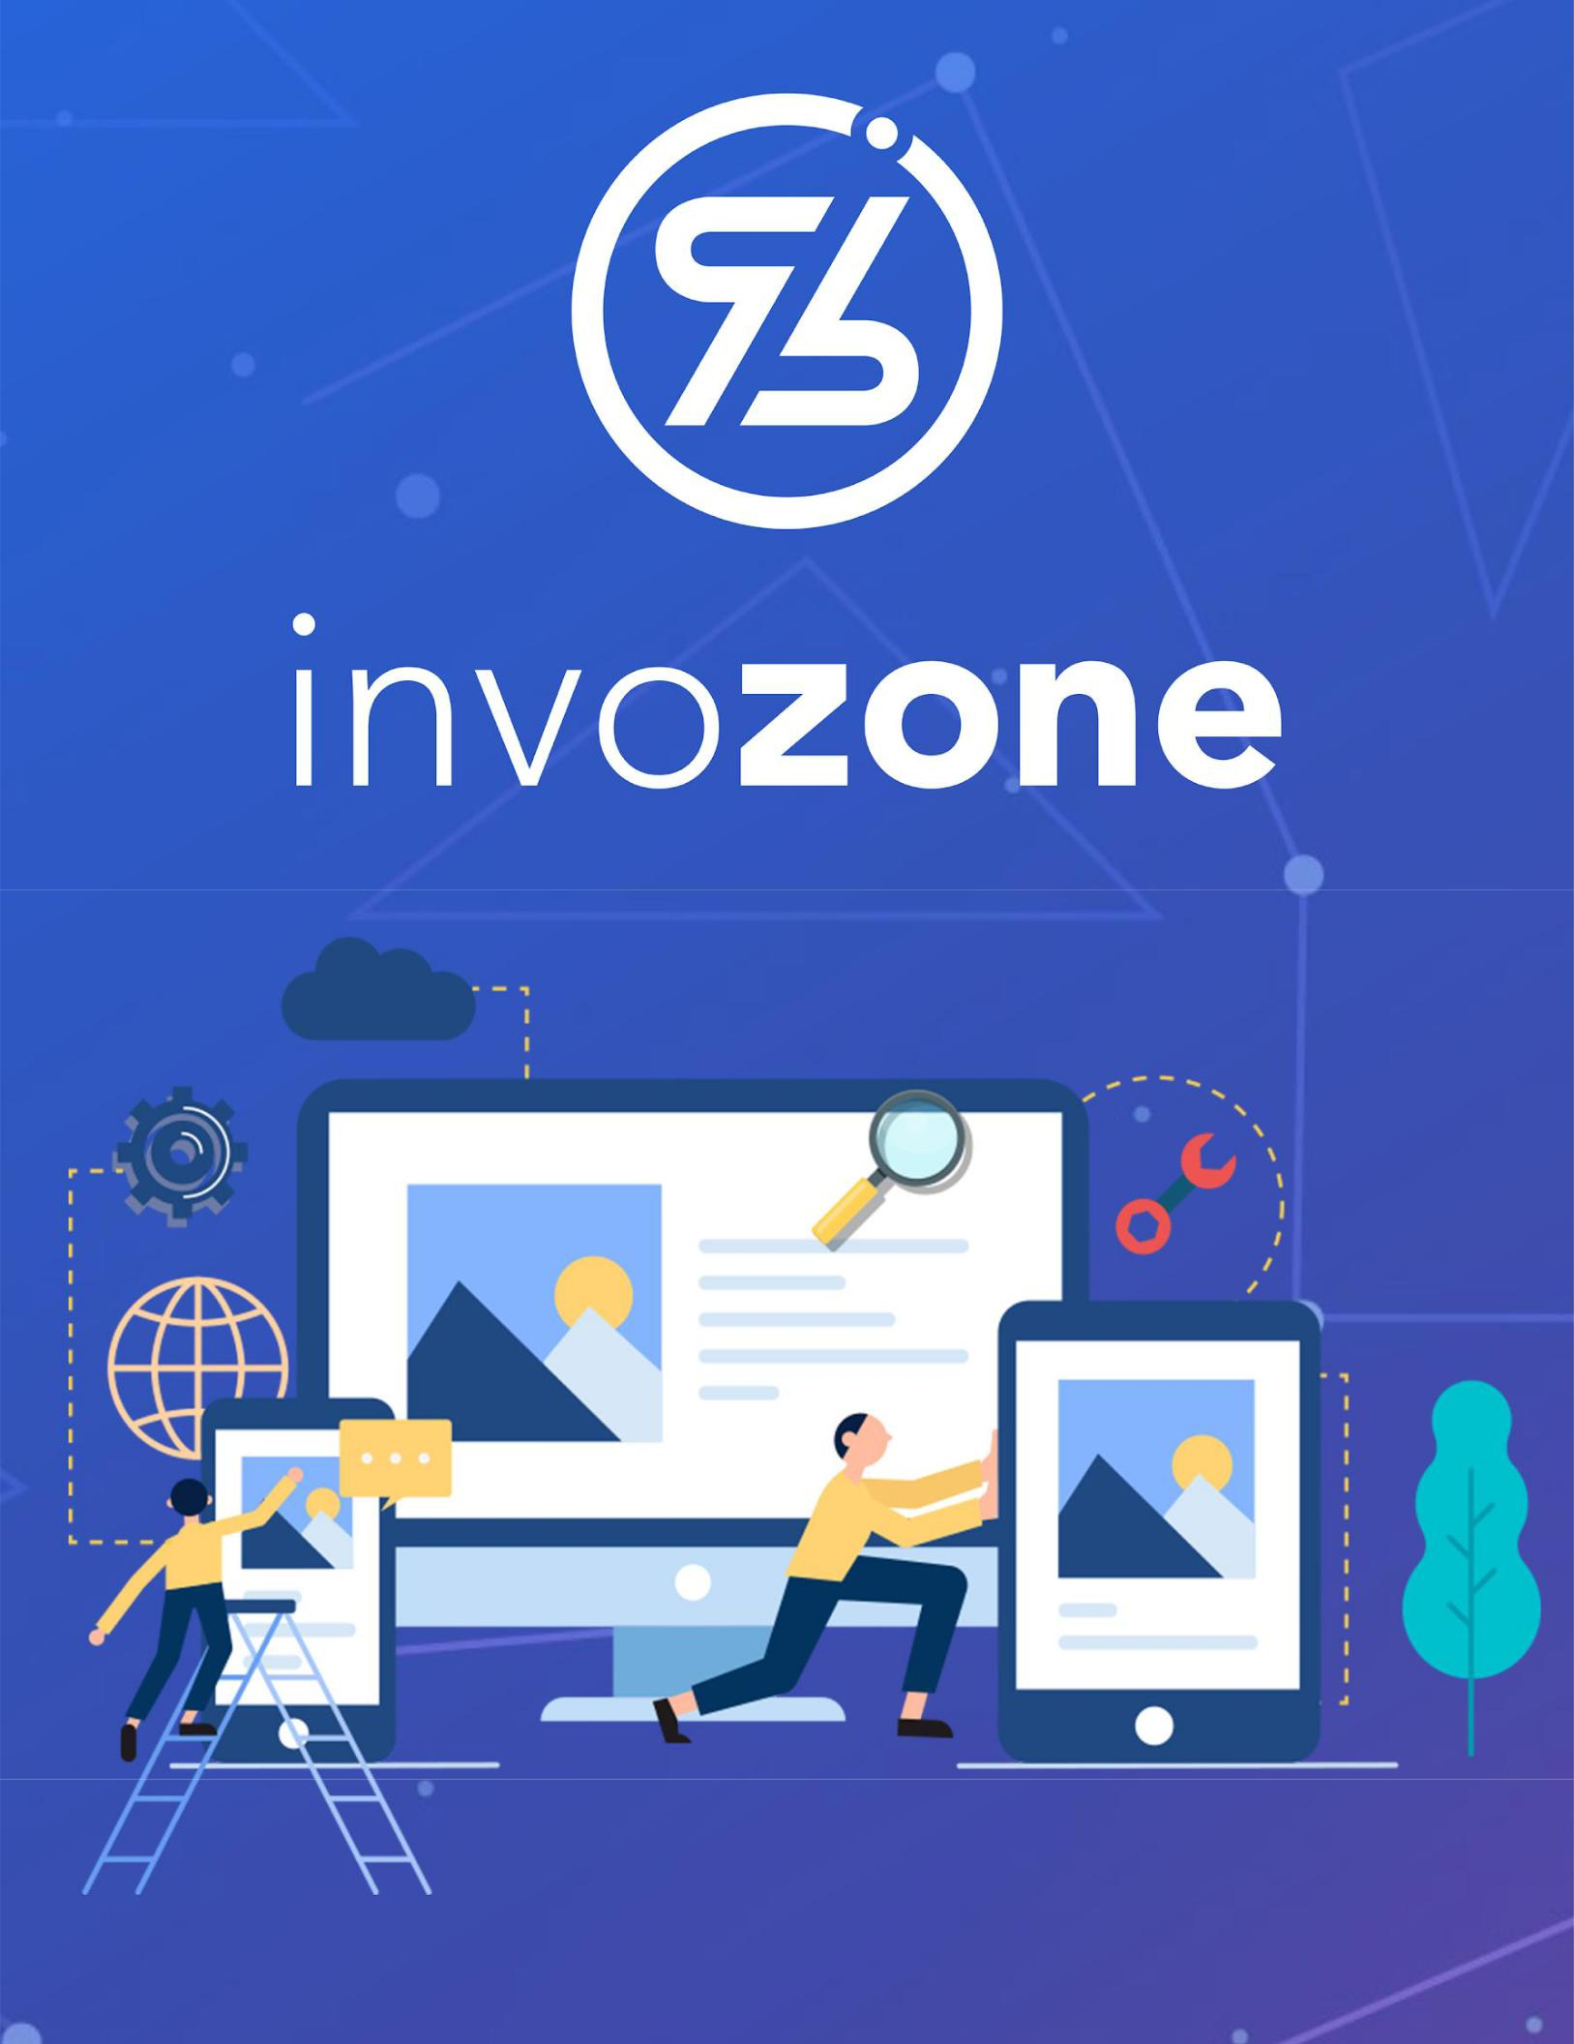

DApps and Types of Blockchain

READING TASK | 2

## Last Updated: December 28, 2021

# INTRODUCTION TO BLOCKCHAIN

## Types of Blockchain

<https://www.youtube.com/watch?v=FcfPU3rYVAk>

<https://www.youtube.com/watch?v=uiHbJPZlT1k>

### Public

Anyone can join and participate in. It is a permissionless environment

### Private

Need invitation or approval before you can join or participate

### Consortium

Multiple organizations can share the responsibilities of maintaining a blockchain. These pre-selected organizations determine who may submit transactions or access the data.

### Permissioned

It has restrictions on who is allowed to participate in the network and in what transactions. Restrictions can also be applied to viewing data on the chain. Participants need to obtain an invitation or permission to join.

Ethereum/EOS/Hyperledger/Polygon

## Decentralized Applications

Decentralized applications (dApps) are digital applications or programs that exist and run on a blockchain or peer-to-peer (P2P) network of computers instead of a single computer. DApps (also called "dapps") are outside the purview and control of a single authority. DApps which are often built on the Ethereum platform can be developed for a variety of purposes including gaming, finance, and social media. For an understanding of the difference between centralized and decentralized applications, read this article [here.](https://www.investopedia.com/terms/d/decentralized-applications-dapps.asp)

## Base currency, Gas, and Virtual Machine

* Types of cryptocurrencies: <https://www.sofi.com/learn/content/understanding-the-different-types-of-cryptocurrency/>
* Gas and Tx Fees: <https://www.youtube.com/watch?v=Yh8cHUB-KoU>
* Smart Contracts
* Wallets – Metamask
* Virtual Machines:

<https://www.youtube.com/watch?v=SFVZRKal7cI>

<https://www.youtube.com/watch?v=G89pJOmwP2M>